Barguna District,Bangladesh
(Established as a district: 28th Feb,1984)
N
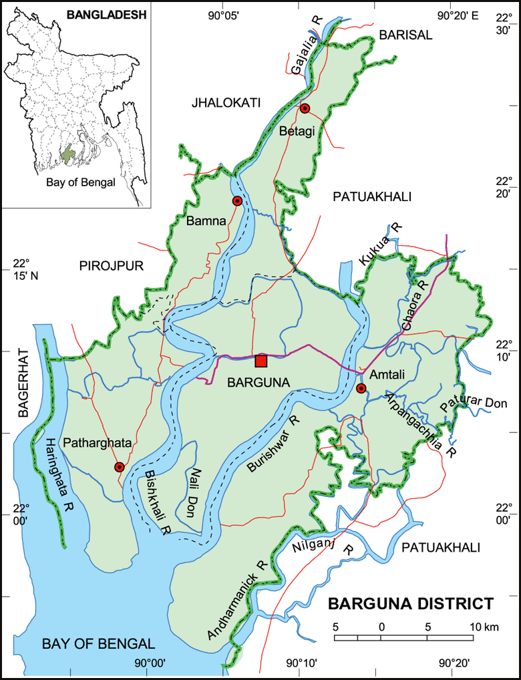
S
Fig-1: Map of Barguna District

Visit Report: Civil Surgeon Office, Barguna
Date of Visit: 23/08/22; Time: 9:30 AM.
Visitor: Md. Abdul Hakim Mazumdar, National Consultant (HEU),
Dr. Md. Emdadul Haque, National Consultant (HEU)
Md. Shamsur Rahman, Junior National Consultant (HEU) &
Dr. Nazmur Rahman Sajib, Junior National Consultant (HEU)

1. We arrived at 9:30 am in the Civil Surgeon Office, Barguna. We discussed with the Civil Surgeon and Deputy Civil Surgeon about the overall activities of the health service system of the district.
2. We also discussed with them about the SSK program and role of the District Hospital and Upazila Health Complexes as well as the role of the health service providers in SSK.
3. The Civil Surgeon was very cordial and he ensured us to provide necessary support to implement SSK services.

Barguna District Health Profile:
Total population: 10,55,171
Upazilla: 6 Powroshova: 3 Union: 42

1. Sadar Hospital: 100 bedded.
2. Upazilla Health complex: 5 (4 of them are 50 Bedded, Taltoli-20 Bedded)
3. Community Clinic: 129
4. Rural Dispensary: 08
5. HFWC: 23

Status in HSS Score From Jan-July: (Total Dist. Hospital-64, Total UHC-423)
Name | Janu | Feb | Mar | April | May | June | July
Barguna D-Hospi | 03 | 07 | 19 | 22 | 21 | 16 | 19
Amtoli UHC | 319 | 200 | 255 | 298 | 207 | 368 | 353
Betagi UHC | 306 | 314 | 304 | 332 | 340 | 337 | 341
Bamna UHC | 221 | 162 | 290 | 230 | 279 | 277 | 279
Pathorghata UHC | 209 | 291 | 347 | 258 | 248 | 270 | 385
Taltoli UHC | - | - | - | - | - | - | -
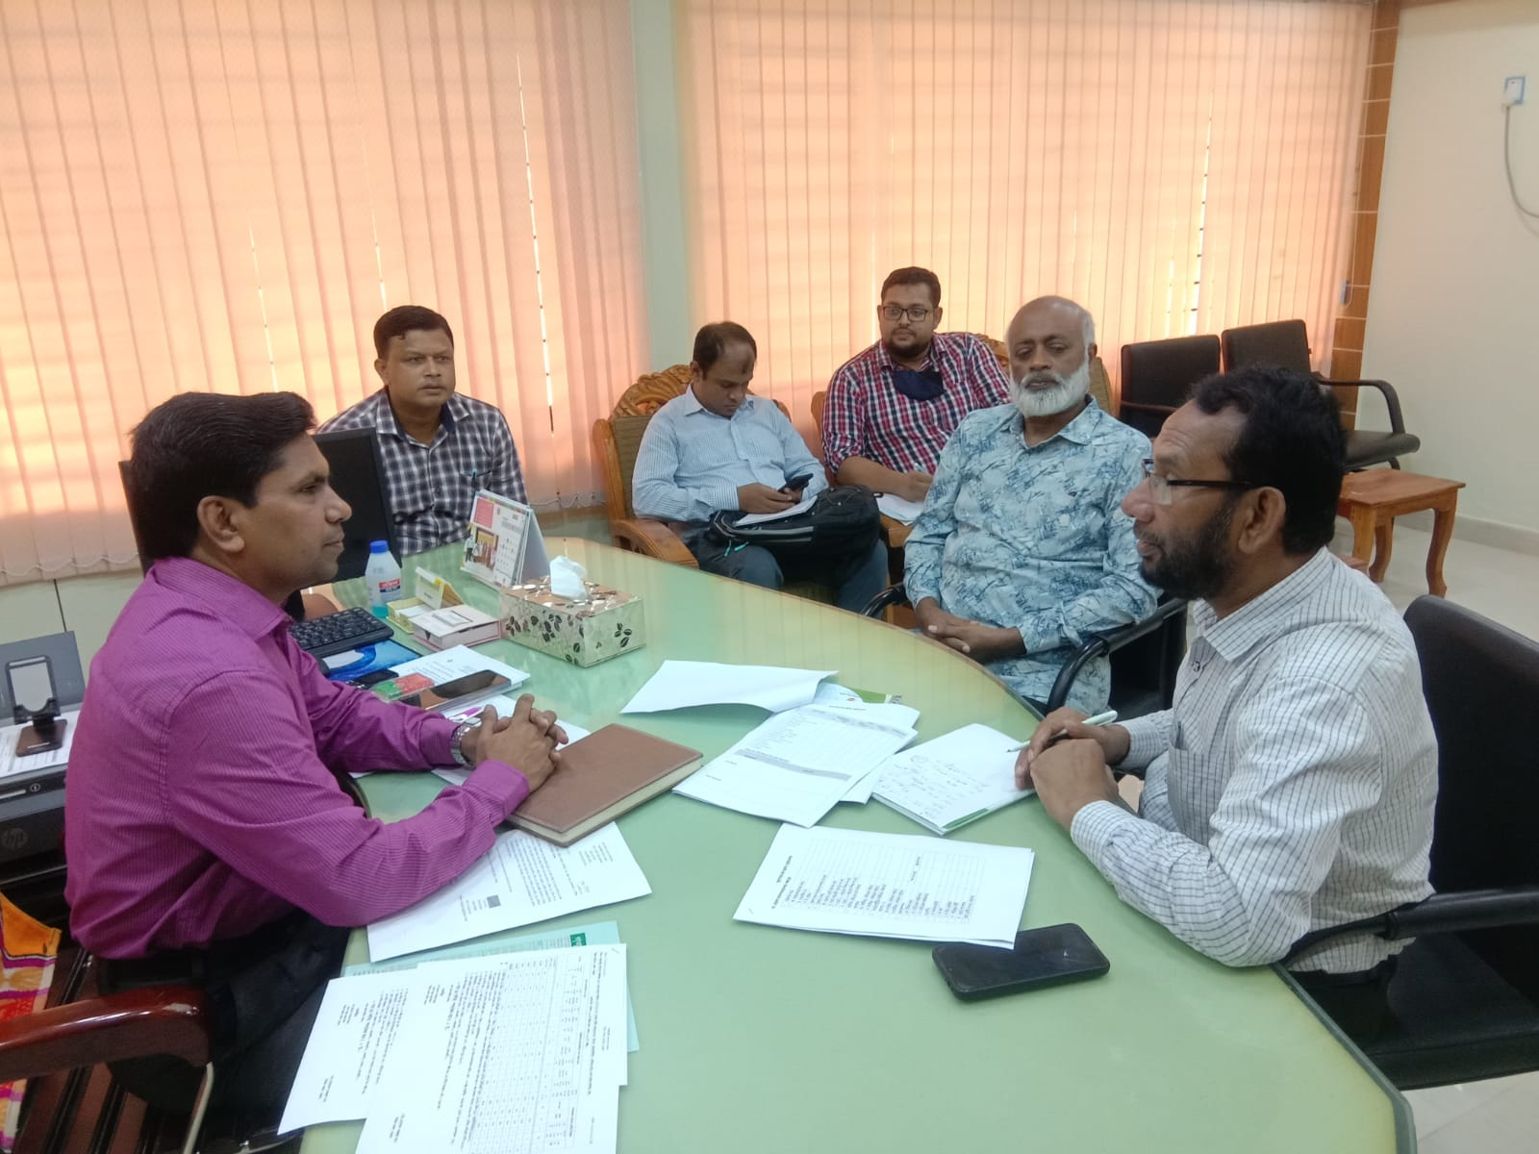
Fig-1: Meeting with Civil Surgeon, Barguna

Visit Report: Barguna Sadar Hospital, Barguna.
Date of Visit: 23/08/22; Time: 10:45 AM.
Visitor: Dr. Md. Emdadul Haque, National Consultant (HEU) &
Dr. Nazmur Rahman Sajib, Junior National Consultant (HEU)

1. We arrived at 10:45 am in the hospital. Superintendent, RMO, consultants were present. We discussed with them about the overall situation of the hospital. We also discussed with them about the SSK program and role of the District Hospital in SSK.
2. There are 10 posts of senior consultants but all the posts are vacant. Out of 11 posts of junior consultant, 7 posts are vacant. Among them, Surgery Gynae, Anesthesiology and Orthopedics are available.
3. There are two cleaners. One cleaner posted in the hospital; another one is from deputation. There is no Aya, ward boy, guard, gardener, electrician and trolley-man. 12 cleaners are supported from the Powroshova. 20 post of outsourcing is created, but only 11 post is approved in recruitment policy. Till now, no one is appointed to work.
4. The infra-structure of this hospital is 100 bedded. The physical condition of the hospital building is satisfactory. There is another 150 bedded infra-structure building available within the hospital campus. There is an administrative approval in 20-10-20 to start as 250 bedded hospital. Drugs, MSR and Diet supply is necessary and the post of 250 bedded human resources are yet not created. Its is under process in Health Ministry.
5. We visited outdoor of the hospital which was crowded with patients. We also observed Emergency, pathology and pharmacy department. The automation of indoor and outdoor is functioning. The information display system was satisfactory but not updated. There was no effective health education system.
6. Cleanliness of the hospital premises and indoor was poor. There are separate operation theatres for performing major operations.
7. There is a small cycle stand close to the main gate. There are many motorcycles parked within the premises.
8. The roof of the hospital was clean and beautiful.
9.There are spaces for SSK Booth and Pharmacy close to the emergency department.
10.There are many “Danbox” throughout the hospital.
11. There is no conference room in the old building but using a room in new building as conference room.
12. There is no facility for caesarean section 24/7.
13. In 2021, total OPD patient was 1,21,486. Indoor admitted patient was 18,613. Bed occupancy rate was 141.8%. Total ANC visit in 2021 was 661. Total delivery was 1101. Among them NVD was 466, C-section was 83.

Human Resources of 100 Bedded Hospital:
Sl. | Designation | No. of Post | Present | Vacant
1. | Superintendent | 01 | 01 | 0
2. | RMO | 01 | 01 | 0
3 | Senior Consultant | 10 | 0 | 10
3. | Junior Consultant | 11 | 04 | 07
4. | Medical Officer | 11 | 04 | 07
5. | Medical Officer (OSD) | 08 | 08 | 0
6. | Nurses (Nursing Super+ Supervisor+ SSN+ SN) | 1+2+74+11  =88 | 1+1+74+5  =81 | 0+1+0+6  =7
7. | Administrative Officer | 01 | 01 | 0
8. | Head Assistant | 01 | 01 | 0
9. | Cashier | 01 | 01 | 0
10. | Accountant cum computer operator | 01 | 01 | 0
11. | MT(Dental) | 02 | 01 | 01
12. | MT (Radiology) | 03 | 01 | 02
13. | MT (Lab) | 05 | 05 | 0
14. | MT(TB) | 0 | 0 | 0
15. | Statistician officer | 01 | 0 | 01
16 | Pharmacist | 03 | 0 | 03
17. | Storekeeper | 01 | 01 | 0
18. | Aya | 03 | 0 | 03
19 | Ward Boy | 0 | 0 | 0
20. | MLSS | 05 | 05 | 0
21. | Cleaner | 01 | 01 | 0
22. | Guard | 03 | 0 | 03
23. | Gardener | 01 | 01 | 0
24 | Outsourcing: | 20(11 approved) | 0 | 0
25 | Driver | 02 | 02 | 0

Status of Building Blocks of C-J Model in the Barguna Sadar Hospital:
Sl | Criteria of C-J Model | Best | Good | Weak
01 | Cycle stand close to the main gate |  |  | √
02 | Health Education |  | √
03 | Cleanliness & beautification |  | √
04 | Separation of patients in out door & indoor |  |  | √
05 | Blood doner list with 24/7 B.T facility |  | √
06 | Death Riview |  |  | √
07 | Reception Desk |  |  | √
08 | Developed Emergency Dept. |  | √
09 | 5S –KAIZEN implementation. |  | √
10 | Community Participation. |  | √
11 | Hospital activities Display |  | √
12 | Corner based service. |  | √
13 | Cash counter for receiving Govt money. | √
14 | Devolped maternal health/labour word. |  |  | √
15 | Devolped paediatric health |  | √
16 | Position in HSS score in July22.  (Best <10; Good 10-20; Weak >20) |  | √
17 | Power point Presentation &Video on UHC |  |  | √
18 | Knowledge about 8th Five Year plan & SDG. |  |  | √
19 | Zero-Tollarance on corruption |  | √

Status in HSS Score From Jan-July (Total Dist. Hospital-64, Total UHC-423)
Name | Janu | Feb | Mar | April | May | June | July
Barguna D-Hospi | 03 | 07 | 19 | 22 | 21 | 16 | 19
Amtoli UHC | 319 | 200 | 255 | 298 | 207 | 368 | 353
BetagiUHC | 306 | 314 | 304 | 332 | 340 | 337 | 341
BamnaUHC | 221 | 162 | 290 | 230 | 279 | 277 | 279
PathorghataUHC | 209 | 291 | 347 | 258 | 248 | 270 | 385
Taltoli UHC | - | - | - | - | - | - | -

Recommendations:
1.There should be a front gate with security for campus protection.
2.For cleaning and beautification, outsourcing staff should be recruited immediately. For waste management, involvement of Powroshova is necessary.
3. 250 bedded hospital should be functioning as soon as possible.
4. All the vacant posts of consultants should be fullfilled. All the vacant posts of 4th class should also be fulfilled immediately
5.Separate sterilizer machine should be added in emergency, dental unit and abor room.
6. Condemetion Board should work to destory all unwanted items.
7. Replication of C-J model will help in development of the quality of care and it should be followed properly.
8.There should be a Complaints and Suggestion box in front of Superintendent room
9.There should be availability of safe drinking water.
10.All the “Danbox” should be remove.
11.Display system should be updated regularly and health education for the patients and their attendants should be introduced.
12.There should be 24/7 facility for caesarean section.

Photos of District Hospital, Barguna taken from the visit are shown below:
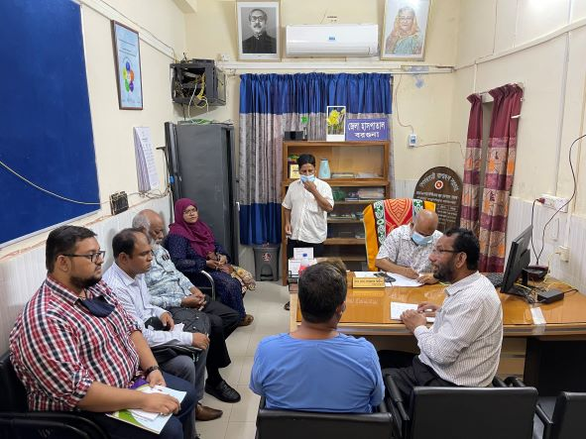
Fig-1: Discussion with Superintendent, RMO and Junior Consultants
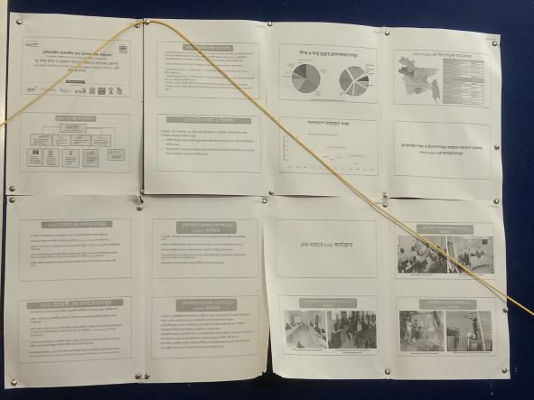
Fig-2: Display board of Superintendent office (Not updated)
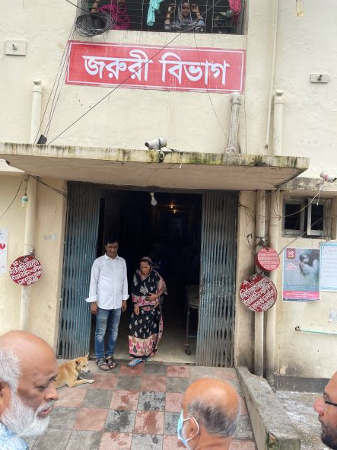
Fig-3: 3 Danboxes at the entrance of Emergency dept.

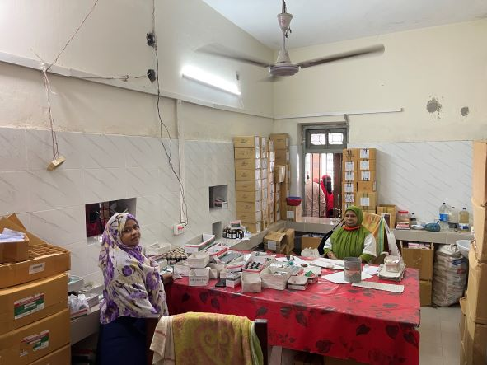
Fig-4: Pharmacy room, not organized

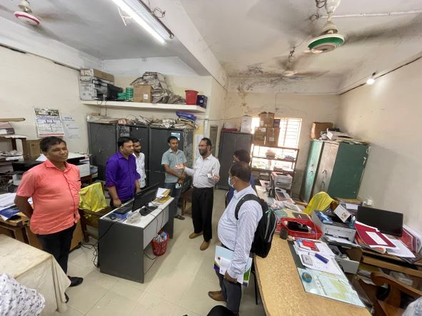
Fig-5: Office room; Files and papers are not organized
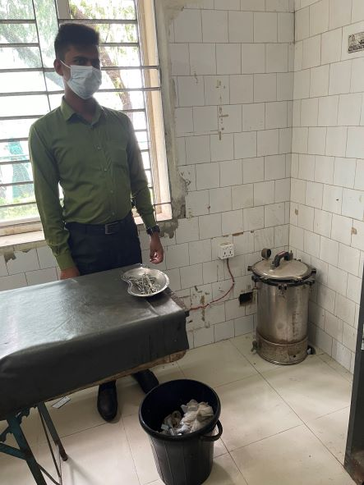
Fig-6: Nonfunctional Sterilizer machine in Emergency Room

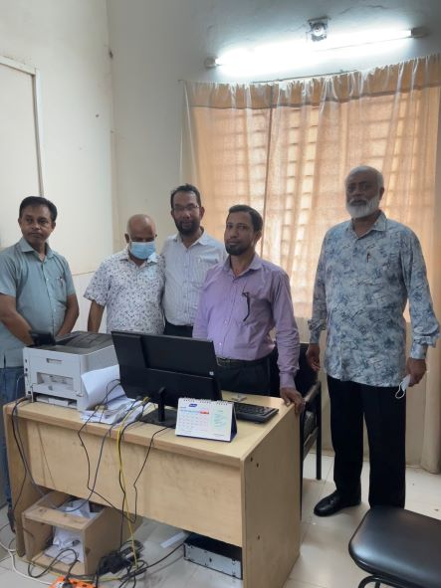
Fig-7: Automation system for revenue collection (Good Practice)

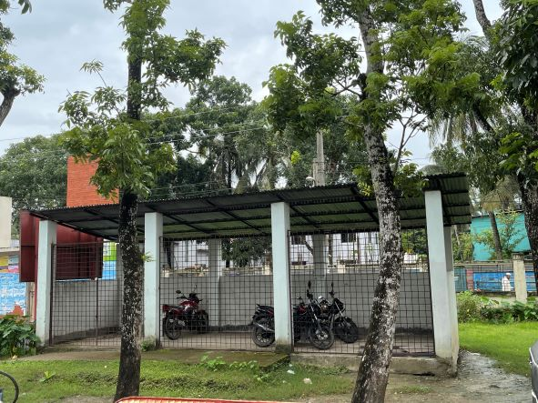
Fig-8: Too small cycle stand close to the main gate
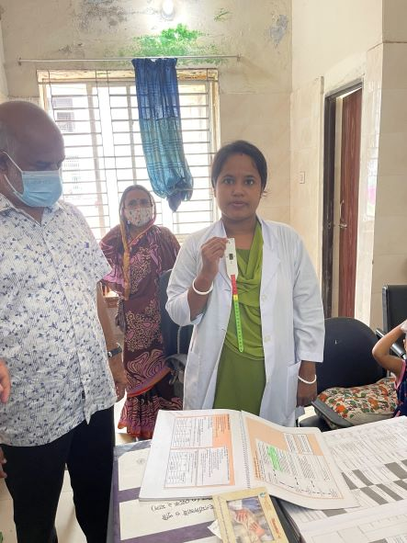
Fig-9: Nutritional assessment system in IMCI corner not functioning

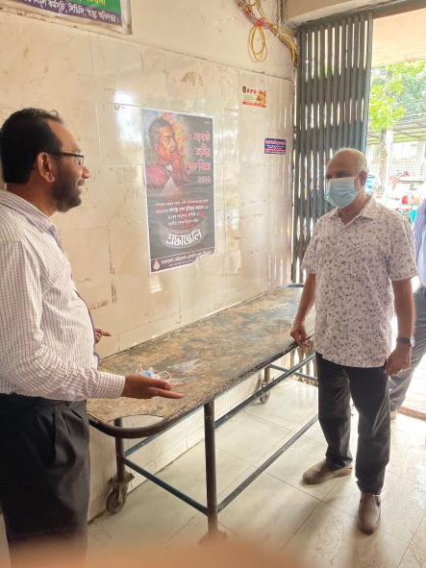
Fig-10: Unclean and uncovered trolley used in Emergency Department
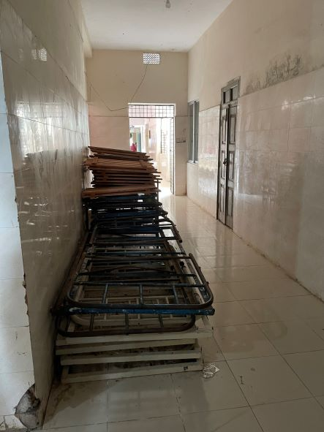
Fig-11: Unwanted items in hospital corridor

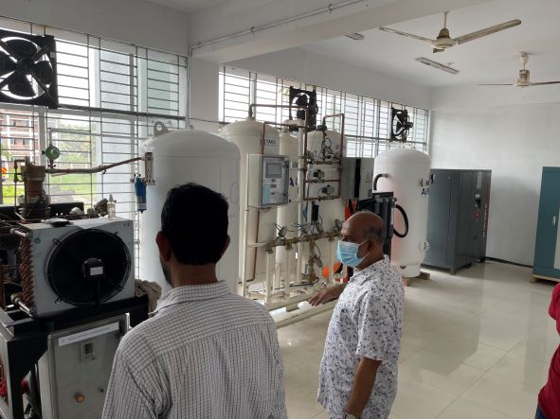
Fig-12: Oxygen generation plant for oxygen support for the hospital (Good Practice)

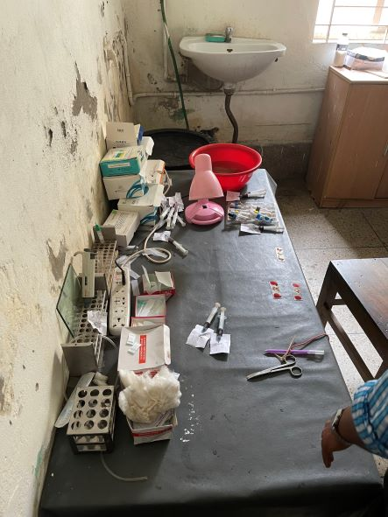
Fig-13: Disorganized items in Pathology room
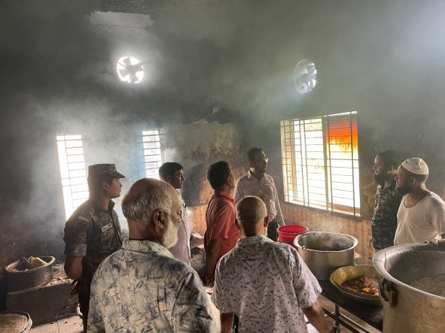
Fig-14: Nonfunctional exhaust fan in the kitchen

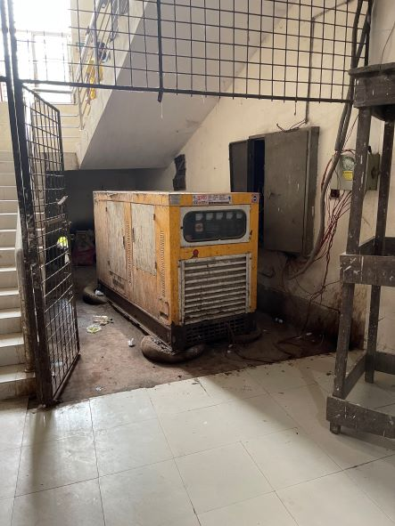
Fig-15: Nonfunctional generator
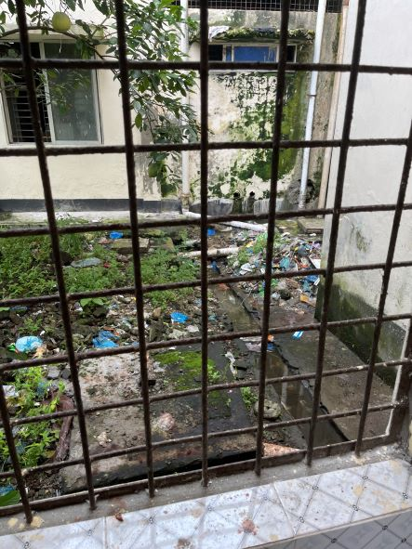
Fig-16: unclean backside of the hospital

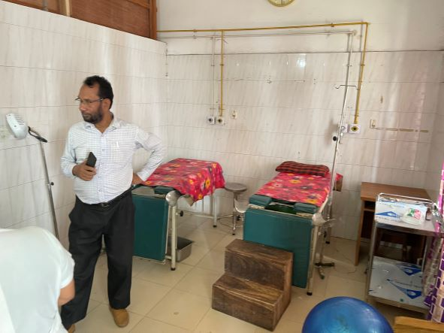
Fig-17: Unclean Labour room and no screen in between labour tables

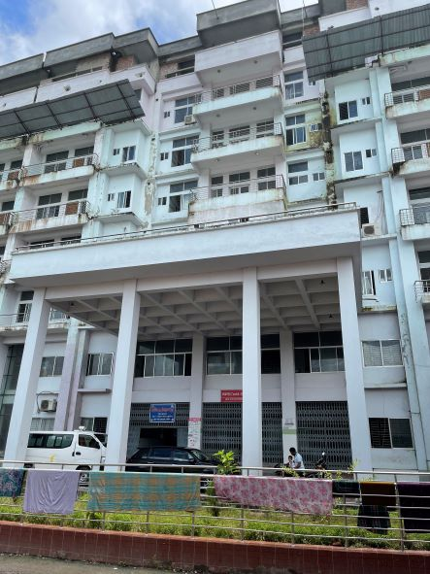
Fig-18: Unused 150 bedded new hospital building

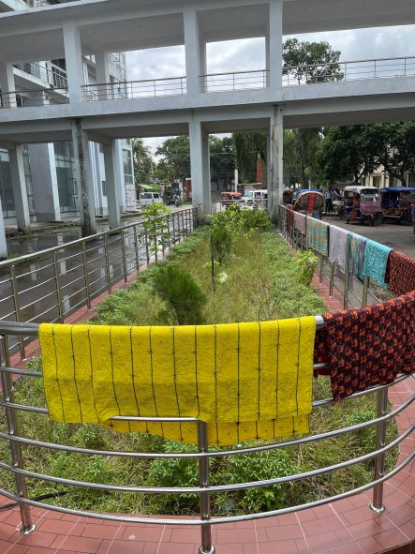
Fig-19: Unclean garden in front of the hospital building

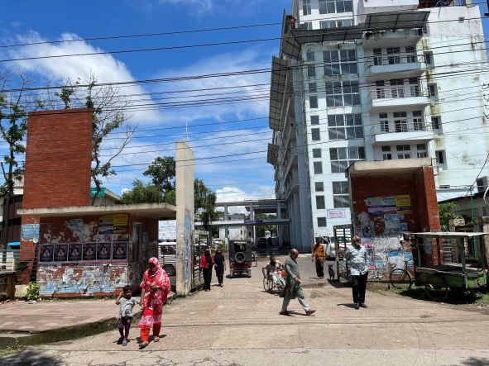
Fig-20: No gate at the entrance of the hospital campus

Visit Report: Betagi Upazila Health Complex, Barguna
Date of Visit: 23/08/22; Time: 12:45 PM.
Visitor: Dr. Md. Emdadul Haque, National Consultant (HEU) &
Dr. Nazmur Rahman Sajib, Junior National Consultant (HEU)

1. We arrived in Bamna UHC at12:45 pm .The post of UH&FPO was vacant.
RMO and other medical officers were present in the health complex. We met with them, discuss about the overall situation of the health complex. There are 7 union under the UHC having 1,10,926 population. There is one Sub-centre, 7 H&FWC and 17 Community Clinic in this Upazilla.
2.The infra-structure of this Upazila Health Complex is 50 bedded. The physical condition of the old part of the building is un-useable. Immediately it should be declared as condemned structure.
3.All the post of Consultants are vacant. So caesarean section is not being performed.
4.There is no cycle stand. There are many motorcycles parked in the premises.
5. We observed emergency, outdoor, pathology and pharmacy department. The information display system was weak.
6.The USG, ECG machine is functioning but X-Ray machine is not functioning.
8.The spaces of emergency is congested. But SSK Booth and Pharmacy cannot be established close to the emergency department. There is no separate O.T
9. Cleanliness of the hospital premises, outdoor and indoor was not satisfactory, but wash room was not clean.
11.The roof of the health complex is not clean. There are many bushes on the roof.
12.There are many “Danbox” throughout the UHC, and advised for removing those immediately.
14. In 2021, total OPD patient was 24,620, in emergency 6152 and in indoor admitted patient was 5878. Bed occupancy rate was 63%. Total ANC 1st visit in 2021 was 302 and total delivery was 46.

Human Resources: 50 Bedded Hospital:
Sl. | Designation | No. of Post | Present | Vacant
1. | UH&FPO | 01 | 0 | 1
2 | RMO | 01 | 01 | 0
3. | Junior Consultant | 10 | 0 | 10
4. | Medical Officer | o3 | 03 | 0
5. | MO(Dental) | 01 | 0 | 01
6. | Medical Officer (OSD) | 09 | 09 | 0
7. | Nurses | 31 | 31 | 0
8. | Mid wives | 05 | 05 | 0
9. | Medical Technologist (Lab) | 03+1 | 02+1 | 01
10. | MT EPI | 01 | 01 | 0
11. | MT(Dental) | 01 | 0 | 01
12 | MT (Radiology) | 01 | 0 | 01
13. | SACMO (UHC+Field) | 08 | 03 | 05
14. | Pharmacist | 02 | 01 | 01
15. | Health Inspector (HI) | 02 | 01 | 01
16. | Sanitary Inspector | 01 | 0 | 01
17. | Assist. Health Inspector | 06 | 03 | 03
18. | Health Assistant | 30 | 19 | 11
19. | CHCP | 17 | 15 | 02
20. | Head Assistant | 01 | 0 | 01
21. | Cashier | 01 | 1(suspended) | 0
22. | Accountant | 01 | 01 | 0
23. | Staticstician | 01 | 0 | 01
24. | OA/Comp.opertor | 03 | 01 | 02
25. | Store Keeper | 01 | 01 | 0
26. | Cardiographer | 01 | 01 | 0
28. | MLSS+Ward boy | 09 | 04 | 05
29. | Cleaner | 05 | 03 | 02
30. | Guard | 02 | 0 | 02
31. | Gardenar | 01 | 01 | 0
32. | Cook | 02 | 0 | 02
33. | Attendent(Lab,Emergen,OT) | 03 | 03 | 0
34. | Driver(Ambulance) | 01 | 01 | 0
35. | Outsourcing: Driver | 01 | 01 | 0
36. | FWA | 39

Status in HSS Score From Jan-July. (Total Dist. Hospital-64, Total UHC-423)
Name | Janu | Feb | Mar | April | May | June | July
Barguna D-Hospi | 03 | 07 | 19 | 22 | 21 | 16 | 19
Amtoli UHC | 319 | 200 | 255 | 298 | 207 | 368 | 353
Betagi UHC | 306 | 314 | 304 | 332 | 340 | 337 | 341
Bamna UHC | 221 | 162 | 290 | 230 | 279 | 277 | 279
Pathorghata UHC | 209 | 291 | 347 | 258 | 248 | 270 | 385
Taltoli UHC | - | - | - | - | - | - | -

Status of Building Blocks of C-J Model in the Betagi UHC:
Sl | Criteria of C-J Model | Best | Good | Weak
01 | Cycle stand close to the main gate |  |  | √
02 | Health Education |  |  | √
03 | Cleanliness & beautification |  |  | √
04 | Separation of patients in out door & indoor |  |  | √
05 | Blood doner list with 24/7 B.T facility |  | √
06 | Birth- death recording |  |  | √
07 | Reception Desk |  |  | √
08 | Developed Emergency Dept. |  |  | √
09 | 5S –KAIZEN implementation. |  |  | √
10 | Community Participation. |  | √
11 | Hospital activities Display |  |  | √
12 | Corner based service. |  | √
13 | Cash counter for receiving Govt money. |  |  | √
14 | Devolped maternal health/labour word. |  |  | √
15 | Devolped paediatric health |  |  | √
16 | Position in HSS score in July22.  (Best= <100; Good= 101-200; Weak= >200) |  |  | √
17 | Power point Presentation &Video on UHC |  |  | √
18 | Knowledge about 8th Five Year plan & SDG. |  |  | √
19 | Zero-Tollarance on corruption |  | √

Recommendations:
1.Reconstruction of the old building must be start immidiately.
2.The post of gynae and anesthesia consultant should be filled up immediately for the development of improved maternal health.
3. Cleanliness and beautification is satisfactory. The local Powroshova must take part in waste management as health complex paid 15,00,000 Tk/year to Powroshova.
4. There should be funtioning OT room for major operation in the health complex.
5. Condemetion Board should work to destory all unwanted items.
6. All the vacant posts of 4th class should be fulfilled immediately.
7. The post of Dental Surgeon and Medical Technologist (Dental), Medical Technology (Radiology)must be fulfilled to start dental& radiology services.
8. Replication of C-J model will help in development of the quality of care and it should be followed properly.
9. There should be a Complaints and Suggestion box in front of UH&FPO room
10. The roof of the health complex building should be cleaned.
11. There should be availability of safe drinking water.
12. All the “Danbox” of the UHC, should be remove.
13.The performance of all services must be improved, because of underutilization of the health complex.

Photos of UHC, Betagi taken from the visit are shown below:
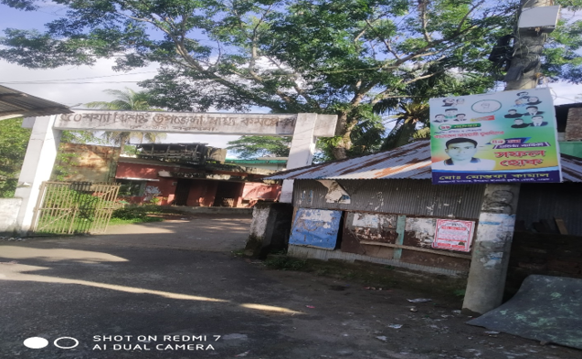
Figure: 01 Gate of the Upazila Health Complex is not identifiable, Betagi, Barguna.
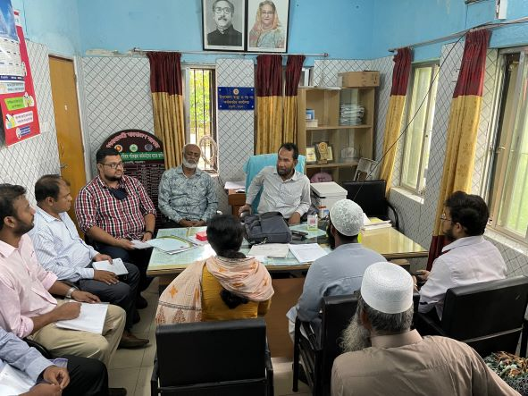Figure 2: Meeting with RMO & MOs in UH&FPO room
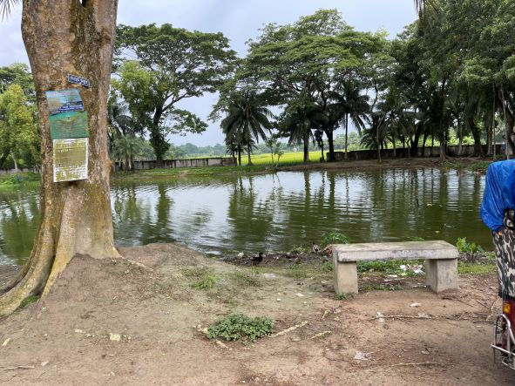
Figure 3: Campus is unprotected due to broken boundary wall.
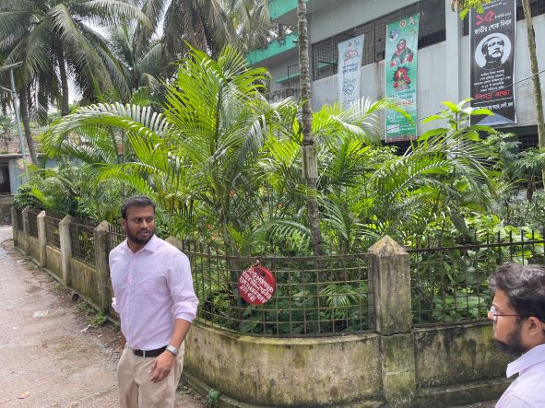Figure 4: Garden in front of the hospital (good practice)
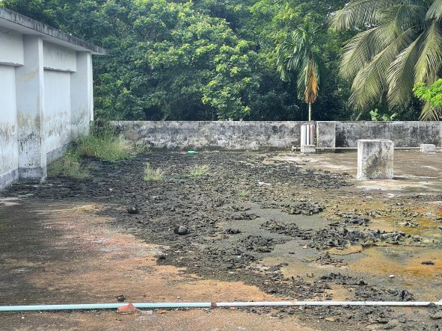Figure 5: Unclean roof of the hospital building
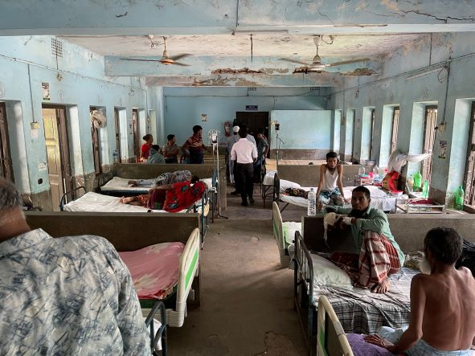
Figure 6: Unclean male medicine ward with chances of brake down of the roof.

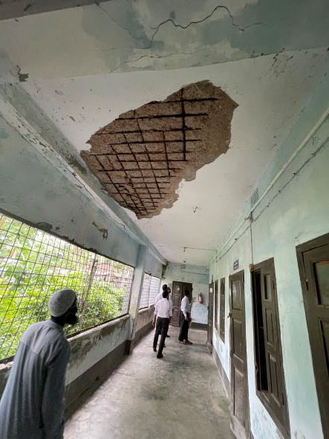Figure 7: In secured corridor of the hospital
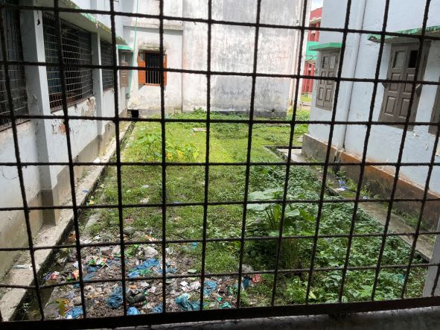Figure 8: Weak waste management system of the hospital
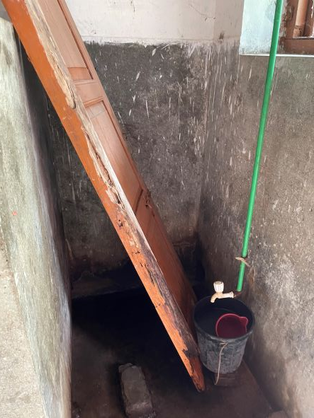Figure 9: Unclean washroom and proper privacy is not maintaining.
am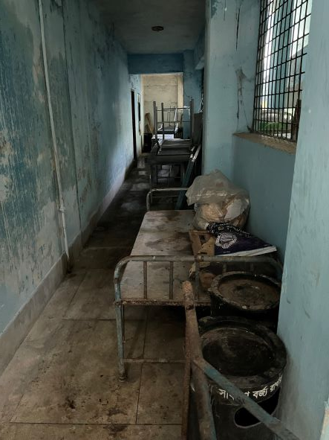BFigure 10: Unwanted items in corridor
Visit Report: Bamna Upazila Health Complex, Barguna
Date of Visit: 24/08/22; Time: 9:45 AM.
Visitor: Dr. Md. Emdadul Haque, National Consultant (HEU) &
Dr. Nazmur Rahman Sajib, Junior National Consultant (HEU)

1. We arrived at 9:45 am in the health complex. But UH&FPO and all the medical officers were present in the health complex.
2. The infra-structure of this Upazila Health Complex is 50 bedded. The physical condition of the hospital building is good. The UHC is 37km. away from Civil Surgeon office, Barguna. There are 4 unions under this UHC.
3. We met with the UH&FPO, RMO and other Medical Officers, discuss with them about the overall situation of the health complex. The post of Gynae and Anaesthesia consultant were vacant, so caesarean section is not being performed.
4. We visited outdoor of the Upazila Health Complex of Bamna. The outdoor was crowded with patients. We also observed Emergency, labour room, pathology and pharmacy department. The information display system was good but not updated. There was no effective health education system.
5. Cleanliness of the hospital premises and indoor was satisfactory. There is separate operation theatre having no equipment.
6. There is no cycle stand close to the main gate. There are many motorcycles parked within the premises.
7. The roof of the health complex is not clean. There are many bushes on the roof.
8. Spaces in emergency is congested. But SSK Booth and Pharmacy can be established close to the emergency department.
9. There are many “Danbox” throughout the UHC, and advised for removing those.
10. There is a well decorated conference room in the UHC.

Health Profile of Bamna UHC, Bamna, Barguna
Total population: 94,036
Union: 4 Sub-centre: 0 FWC: 4 Community Clinic: 08
Human Resources: 50 Bedded Hospital:
Sl. | Designation | No. of Post | Present | Vacant
1. | UH&FPO | 1 | 1 | 0
2. | Junior Consultant | 11 | 0 | 11
3. | Medical Officer | 2 | 2 | 0
4. | Medical Officer (OSD) | 10 | 10 | 0
5. | Nurses | 21 | 20 | 01
6. | Mid wives | 04 | 04 | 0
7. | Medical Technologist (Lab) | 2 | 0 (1 deputed from other UHC) | 2
8. | MT EPI | 1 | 1 | 0
9. | Dental Technologist | 1 | 0
10. | MT (Radiology) | 1 | 0
11. | SACMO | 3 | 3
12. | Health Inspector (HI) | 1 | 1
13. | Assist. Health Inspector | 4 | 4
14. | Health Assistant | 18 | 18
15. | CHCP | 09 | 08
16 | Head Assistant | 01 | 0 | 1deputed
17 | Accountant | 1 | 0 | 1
18. | Statistician | 2 | 1 | 1
19. | MLSS | 4 | 2 | 2
20. | Cleaner | 5 | 2 | 3
21. | Guard | 02 | 01 | 01
22. | FWA
23. | Outsourcing: Driver | 01 | 01 | 0

Status in HSS Score From Jan-July. (Total Dist. Hospital-64, Total UHC-423)
Name | Janu | Feb | Mar | April | May | June | July
Barguna D-Hospi | 03 | 07 | 19 | 22 | 21 | 16 | 19
Amtoli UHC | 319 | 200 | 255 | 298 | 207 | 368 | 353
BetagiUHC | 306 | 314 | 304 | 332 | 340 | 337 | 341
BamnaUHC | 221 | 162 | 290 | 230 | 279 | 277 | 279
PathorghataUHC | 209 | 291 | 347 | 258 | 248 | 270 | 385
Taltoli UHC | - | - | - | - | - | - | -

Status of Building Blocks of C-J Model in the Bamna UHC:
Sl | Criteria of C-J Model | Best | Good | Weak
01 | Cycle stand close to the main gate |  |  | √
02 | Health Education |  |  | √
03 | Cleanliness & beautification |  | √
04 | Separation of patients in out door & indoor |  |  | √
05 | Blood doner list with 24/7 B.T facility |  | √
06 | Birth- death recording |  |  | √
07 | Reception Desk |  |  | √
08 | Developed Emergency Dept. |  | √
09 | 5S –KAIZEN implementation. |  |  | √
10 | Community Participation. |  | √
11 | Hospital activities Display |  |  | √
12 | Corner based service. |  | √
13 | Cash counter for receiving Govt money. |  |  | √
14 | Devolped maternal health/labour word. |  |  | √
15 | Devolped paediatric health |  |  | √
16 | Position in HSS score in July22.  (Best= <100; Good= 101-200; Weak= >200) |  |  | √
17 | Power point Presentation &Video on UHC |  |  | √
18 | Knowledge about 8th Five Year plan & SDG. |  |  | √
19 | Zero-Tollarance on corruption |  | √

Recommendations:
1. For better office management, the post of Head Assistant and Accountant is very important. Both the post are lying vacant. It should be filled up immediately.
2. Cleanliness and beautification is satisfactory. The local Powroshova must take part in waste management.
3. There should be funtioning OT room for major operation in the health complex.
4. Labor room is functioning.
5. Condemetion Board should work to destory all unwanted items.
6. All the post of consultants specially Gynae consultant and Anesthesia should be filled up immediately.
7. Medical Technologist (Dental), Medical Technologist (Radiology), Cardiographer post must be fullfilled.
9. Replication of C-J model will help in development of the quality of care and it should be followed properly.
10. All the vacant posts of 4th class should be fulfilled immediately.
11. Radiogical service is functioning by local arrangement. Vaccant post of radiographer should be fulfilled.
12. There should be a Complaints and Suggestion box in front of UH&FPO room
13. The roof of the health complex building should be cleaned.
14. There should be availability of safe drinking water.
15. All the “Danbox” of the UHC, should be removed.

Photos of UHC, Bamna taken from the visit are shown below:
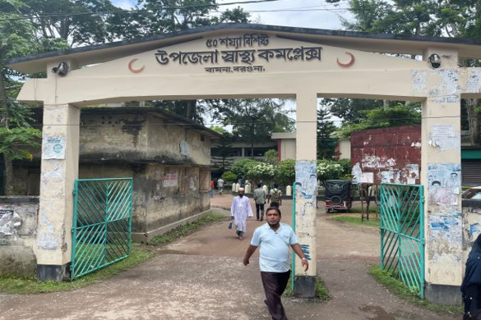
Fig 1. Upazilla Health Complex, Bamna
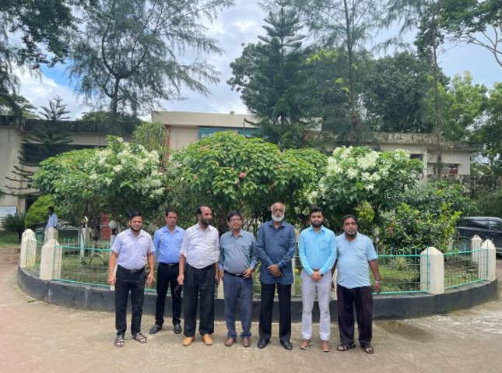
Fig 2: Beautiful garden in front of the UHC
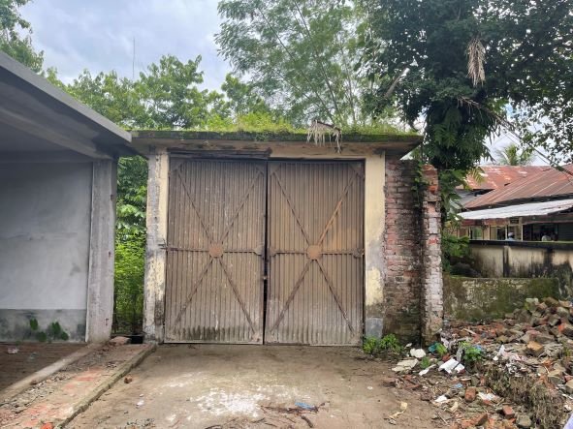
Fig 3. Bushes on the roof of the Ambulance garage

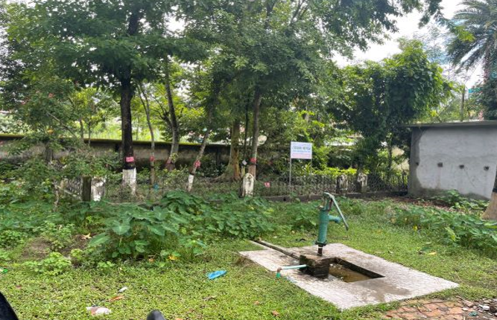
Fig 4: Unclean campus
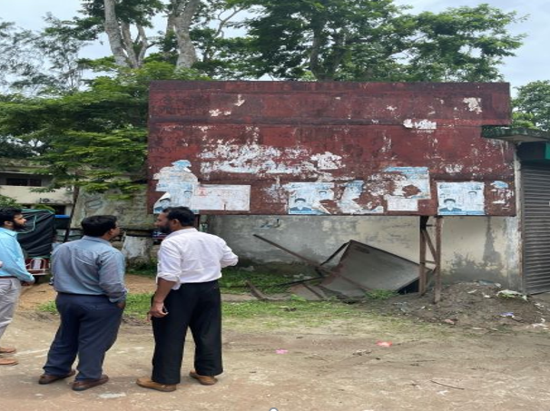
Fig-5: Old and broken billboard hampering beautification
Fig-4: Unused signboard inside UHC
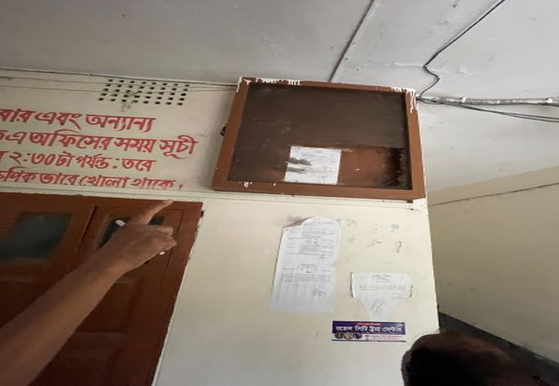
Fig-6: Notice board not placed in proper position
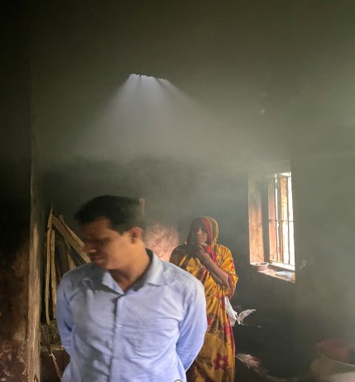
Fig-7: Nonfunctional exhaust fan in the kitchen
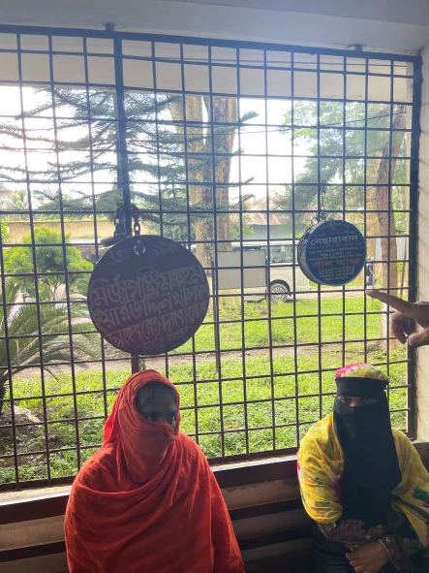
Fig 8: Danbox in hospital corridor
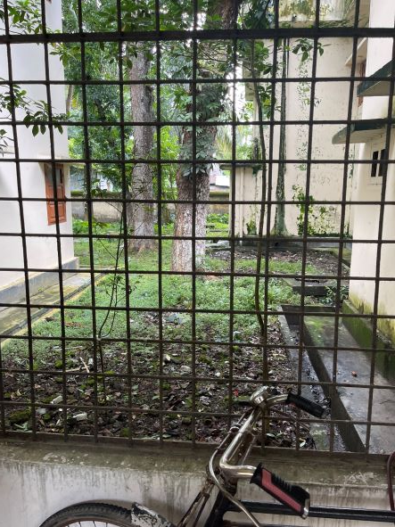
Fig-9: Unclean area beside health complex corridor

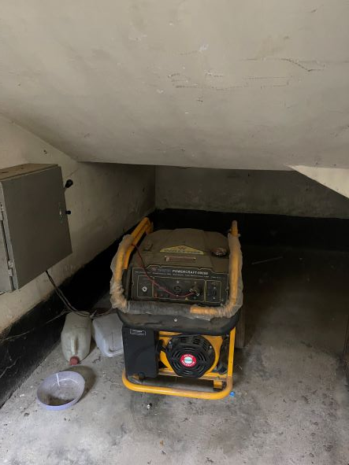
Fig 10: Functioning generator donated by Upazilla Parishad

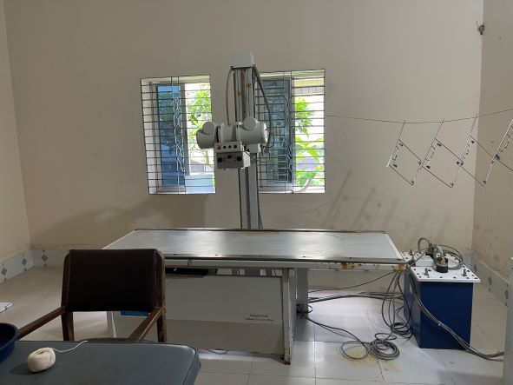
Fig-11: Functional X-ray facility by local arrangement
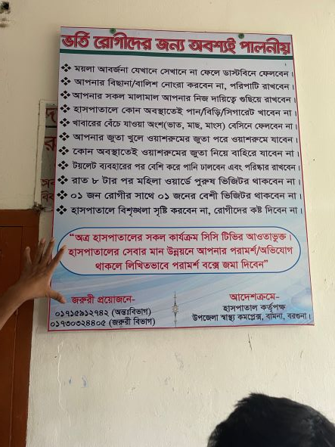
Fig-12: Instructions for patients and attendants (good practice)
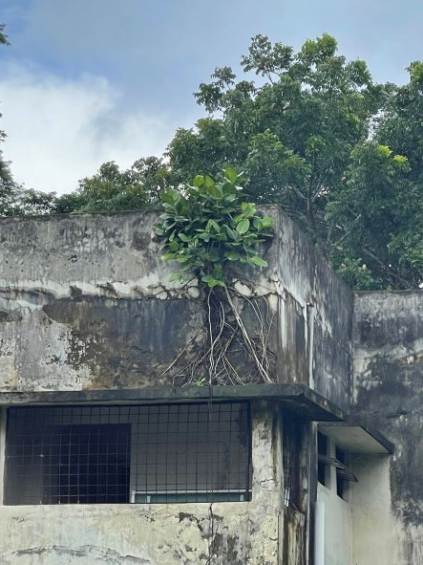
Fig-13: Unclean Building roof filled with shrubs
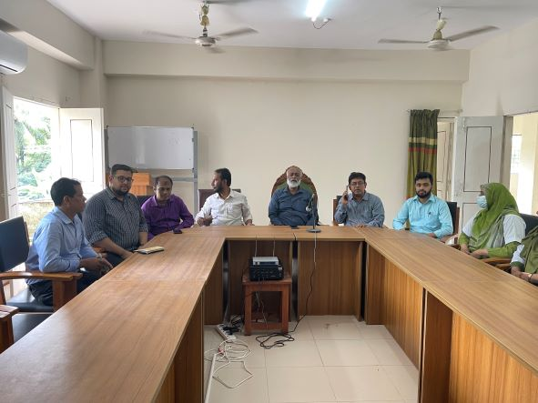
Fig-14: Beautiful conference room
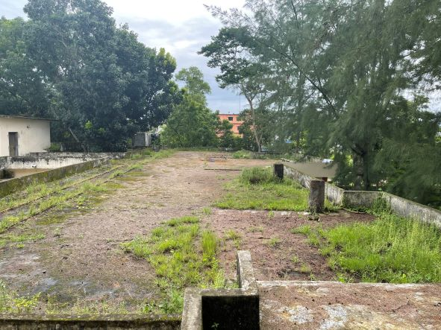
Fig-15: Unclean Building roof filled with shrubs

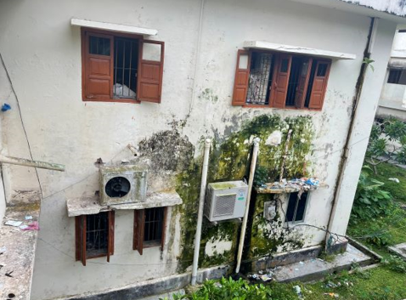
Fig-16: Unclean wall and shades of UHC building

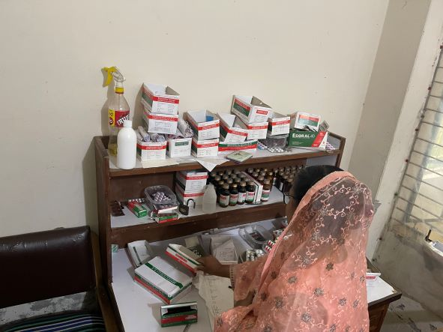
Fig-17: Pharmacy of UHC (disorganized)
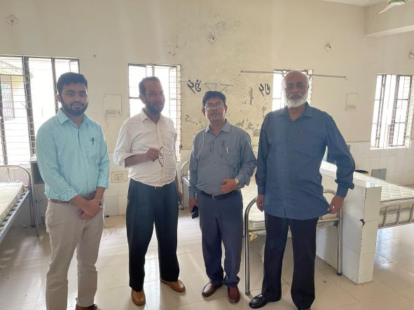
Fig-18: Proposed pediatric ward for UHC
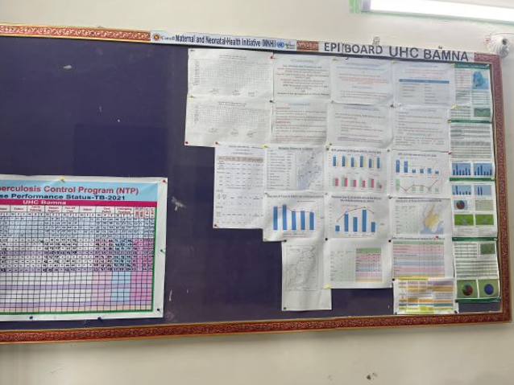

Fig-19: Display system needs to be updated

Visit Report: Pathorghata Upazila Health Complex, Barguna
Date of Visit: 24/08/22; Time: 12:45 PM.
Visitor: Dr. Md. Emdadul Haque, National Consultant (HEU) &
Dr. Nazmur Rahman Sajib, Junior National Consultant (HEU)

1. We arrived at 12:45 pm in the health complex. UH&FPO and all the medical officers were present in the health complex. We met with them, discuss about the overall situation of the health complex
2.The infra-structure of this Upazila Health Complex is 50 bedded. The population of the Upazilla is 1,92,663 having 7 unions, one Union Sub-centre- five H&FWC and 21 Community Clinic. The physical condition of the hospital building is good. The dranage system of the health complex is blocked.So devloped a water-loaging area3.All the post of Consultants are vacant and consultant anesthesia-resigned from the post. So caesarean section is not being performed. The post of Dental surgeon & MT(Dental) is vacant. So dental service is not possible.
4.There is no cycle stand . There are many motorcycles parked in the premises.

5.The outdoor was crowded with patients. We also observed emergency, pathology and pharmacy department. The information display system was weak.
6. There was no effective health education system.
7.Ultra-sonographic, ECG, service is functioning but X-Ray service is not functioning. A packet of X-Ray machine is not opened and installed for long five years.
8. The spaces of emergency is congested. But SSK Booth and Pharmacy can be established close to the emergency department.

9. Cleanliness of the hospital premises, outdoor and indoor was satisfactory, but wash room was not clean.
10.There is a separate OT having no equipment.
11.The roof of the health complex is not clean. There are many bushes on the roof.
12.There are many “Danbox” throughout the UHC, and advised for removing those immediately.
13.There is a small conference room in the UHC close to the office of the UH&FPO.
14.In 2021, total OPD patient was 24,620,in emergency 6152 and in indoor admitted patient was 5878. Bed occupancy rate was 85.5%. Total ANC 1st visit in 2021 was 129 and total delivery was 52.

Human Resources: 50 Bedded Hospital:
Sl. | Designation | No. of Post | Present | Vacant
1. | UH&FPO | 01 | 01 | 0
2 | RMO | 01 | 01 | 0
3. | Junior Consultant | 11 | 01(Anesth,resign) | 10
4. | Medical Officer | o3 | 03 | 0
5. | MO(Dental) | 01 | 0 | 01
6. | Medical Officer (OSD) | 10 | 10 | 0
7. | Nurses | 32 | 32 | 0
8. | Mid wives | 05 | 05 | 0
9. | Medical Technologist (Lab) | 03 | 01mT | 03
10. | MT EPI | 01 | 01 | 0
11. | MT(Dental) | 01 | 0 | 01
12 | MT (Radiology) | 01 | 0 | 01
13. | SACMO (UHC+Field) | 09 | 01 | 08
14. | Pharmacist | 03 | 0 | 03
15. | Health Inspector (HI) | 03 | 01 | 02
16. | Sanitary Inspector | 01 | 01 | 0
17. | Assist. Health Inspector | 08 | 04 | 04
18. | Health Assistant | 40 | 33 | 07
19. | CHCP | 21 | 20 | 01
20. | Head Assistant | 01 | 01 | 0
21. | Cashier | 01 | 01 | 0
22. | Accountant | 01 | 0 | 0
23. | Staticstician | 01 | 0 | 0
24. | OA/Comp.opertor | 03 | 0 | 03
25. | Store Keeper | 01 | 0 | 01
26. | Cardiographer | 01 | 01 | 0
28. | MLSS+Ward boy | 08 | 04 | 04
29. | Cleaner | 05 | 01 | 04
30. | Guard | 02 | 02 | 0
31. | Gardenar | 01 | 01(Depu.Bargu) | 0
32. | Cook | 02 | 01 | 01
33. | Attendent(Lab,Emergen,OT) | 03 | 03 | 01
34. | Driver(Ambulance) | 01 | 01 | 0
35. | Outsourcing: Driver | 01 | 01 | 0
36. | FWA | 39 | 27 | 12

Status in HSS Score From Jan-July. (Total Dist. Hospital-64, Total UHC-423)
Name | Janu | Feb | Mar | April | May | June | July
Barguna D-Hospi | 03 | 07 | 19 | 22 | 21 | 16 | 19
Amtoli UHC | 319 | 200 | 255 | 298 | 207 | 368 | 353
BetagiUHC | 306 | 314 | 304 | 332 | 340 | 337 | 341
BamnaUHC | 221 | 162 | 290 | 230 | 279 | 277 | 279
PathorghataUHC | 209 | 291 | 347 | 258 | 248 | 270 | 385
Taltoli UHC | - | - | - | - | - | - | -

Status of Building Blocks of C-J Model in the Pathorghata UHC:
Sl | Criteria of C-J Model | Best | Good | Weak
01 | Cycle stand close to the main gate |  |  | √
02 | Health Education |  | √
03 | Cleanliness & beautification |  |  | √
04 | Separation of patients in out door & indoor |  |  | √
05 | Blood doner list with 24/7 B.T facility |  | √
06 | Birth- death recording |  |  | √
07 | Reception Desk |  |  | √
08 | Developed Emergency Dept. |  | √
09 | 5S –KAIZEN implementation. |  |  | √
10 | Community Participation. |  | √
11 | Hospital activities Display |  |  | √
12 | Corner based service. |  | √
13 | Cash counter for receiving Govt money. |  |  | √
14 | Devolped maternal health/labour word. |  |  | √
15 | Devolped paediatric health |  |  | √
16 | Position in HSS score in July22.  (Best= <100; Good= 101-200; Weak= >200) |  |  | √
17 | Power point Presentation &Video on UHC |  |  | √
18 | Knowledge about 8th Five Year plan & SDG. |  |  | √
19 | Zero-Tollarance on corruption |  | √

Recommendations:
1.The dranage system of the health complex should be improved The local powroshova must take part in solving the problame.
2.All the post of consultants specially gynae and anesthesia should be filled up immediately for the development of improved maternal health.
2. Cleanliness and beautification is satisfactory. The local Powroshova must take part in waste management.
3. There should be funtioning OT room for major operation in the health complex.
5. Condemetion Board should work to destory all unwanted items.
6. All the vacant posts of 4th class should be fulfilled immediately.
7. The post of Dental Surgeon and Medical Technologist (Dental), Medical Technology (Radiology)must be fulfilled to start dental& radiology services.
8. Replication of C-J model will help in development of the quality of care and it should be followed properly.
14. There should be a Complaints and Suggestion box in front of UH&FPO room
15. The roof of the health complex building should be cleaned.
16. There should be availability of safe drinking water.
17. All the “Danbox” of the UHC, should be remove.
18.The performance of all services must be improved, because of underutilization of the health complex.

Photos of UHC, Pathorghata taken from the visit are shown below:
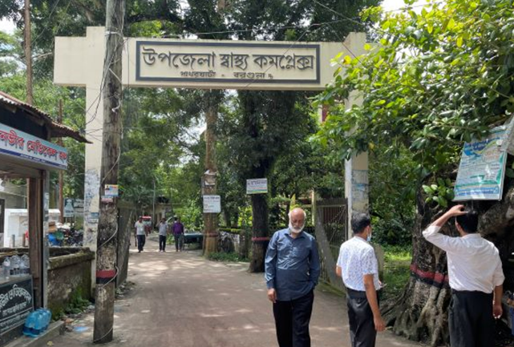
Fig 1: UHC gate
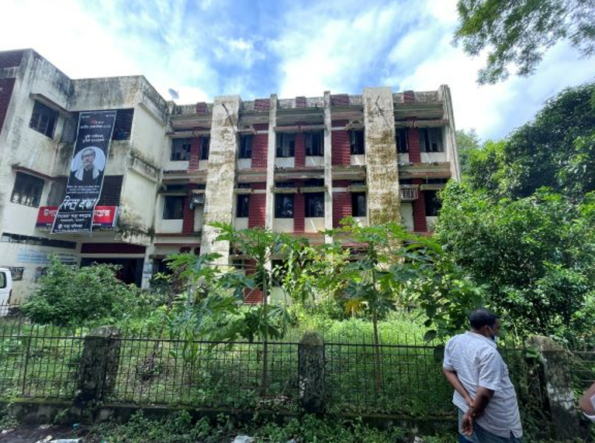
Fig 2: Unclean garden
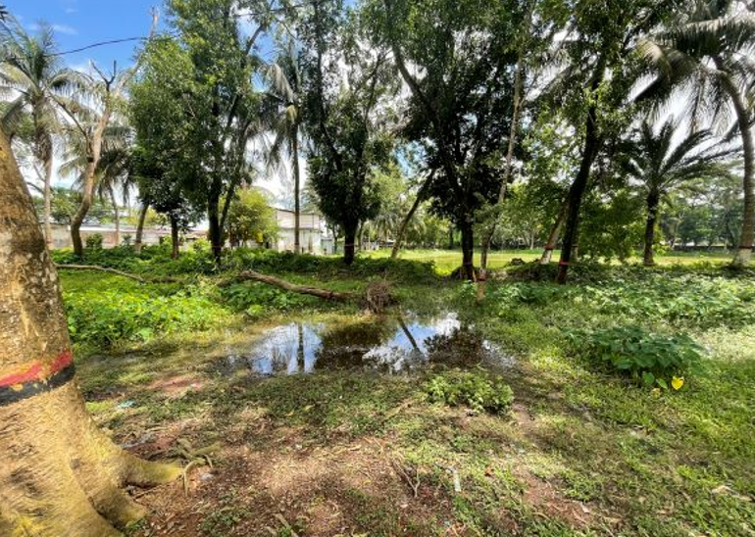
Fig 3: Unclean Campus

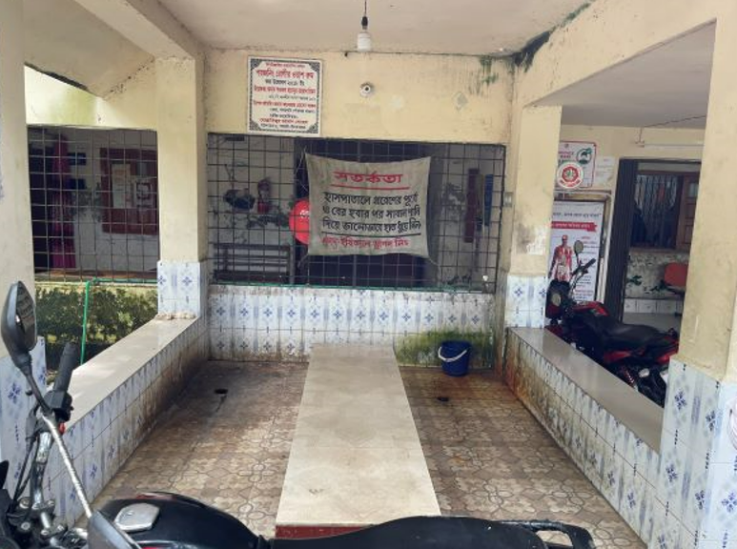
Fig 4: Privacy not maintained in poison washing center
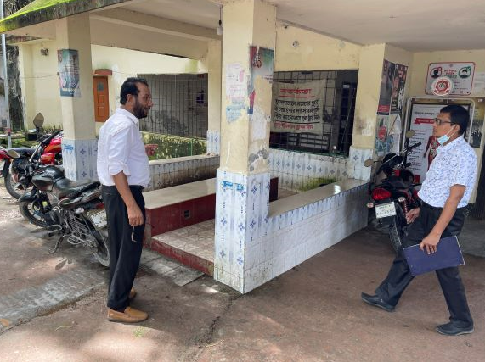
Fig 5: Motorcycles scattered in hospital premises as there are no motorcycle stand
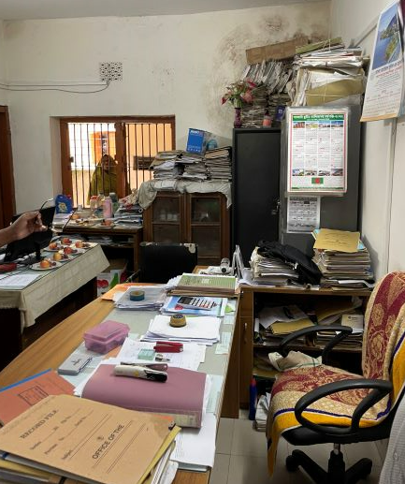
Fig 6: Disorganized file management in office
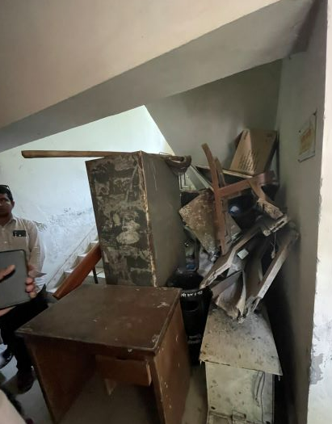
Fig 7: Unwanted items in the corridor

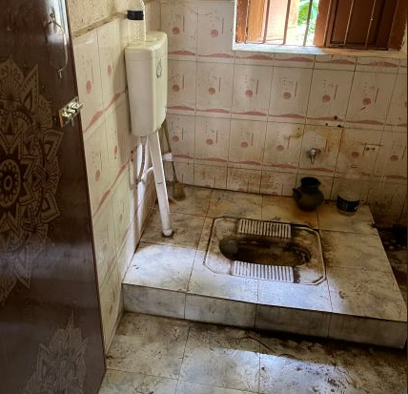
Fig 8: Unclean toilets in the hospital

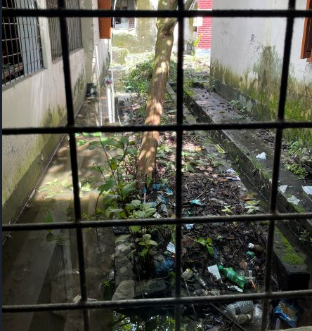
Fig 9: Side of hospital building is filled with dirty materials

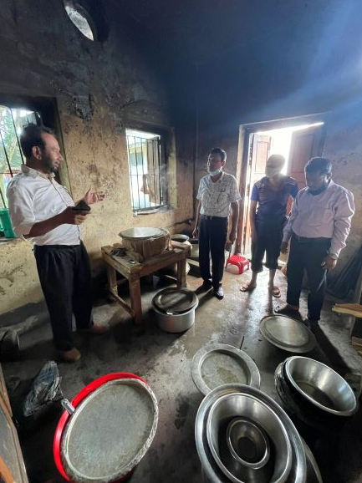
Fig 10: Unclean kitchen with non-functioning exhaust fan
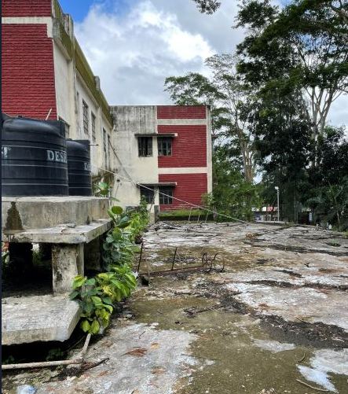
Fig 11: Unclean roof of the hospital building

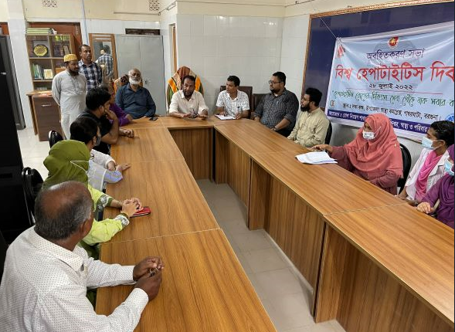
Fig 12: Small conference room attached with UHFPO office

Visit Report: Amtoli Upazila Health Complex, Barguna
Date of Visit: 25/08/22; Time: 8:45 AM.
Visitor: Dr. Md. Emdadul Haque, National Consultant (HEU) &
Dr. Nazmur Rahman Sajib, Junior National Consultant (HEU)

1. We arrived at 8:45 am in the health complex. But no medical officer except EMO was present in the health complex.
2. The infra-structure of this Upazila Health Complex is 50 bedded. The physical condition of the hospital building is good. The UHC is situated close to the high way. There are 7 unions under this UHC.
3. We met with the RMO and other Medical Officers, discuss with them about the overall situation of health complex. The post of Gynae and Anaesthesia consultant was vacant, so caesarean section is not performed.
4. We visited outdoor of the Upazila Health Complex of Amtoli. The outdoor was crowded with patients. We observed OPD, Emergency, labour room, pathology and pharmacy department. There are two medical technologist (Lab). The information display system was better than any other UHC of Barguna district, but the health education system is weak.
5. Cleanliness of the hospital premises and indoor was satisfactory. There is a separate operation theatre but not functioning.
6. There is no cycle stand close to the main gate. There are many motorcycles parked within corridor.
7.The roof of the health complex is not clean. There are many bushes and unwanted hospital beds and other items on the roof.
8.There are many spaces in emergency, SSK Booth and Pharmacy can easily be established there.
9.There are many “Danbox” throughout the UHC, and advised for removing those immediately.
10.The UHC was awarded by “Health Minister’s Award” in 2015.
Health Profile of Amtoli UHC, Amtoli, Barguna
Total population: 244,438
Union: 7 Sub-centre: 2 FWC: 7 Community Clinic: 29

Human Resources: 50 Bedded Hospital:
Sl. | Designation | No. of Post | Present | Vacant
1. | UH&FPO | 1 | 1 | 0
2. | Junior Consultant | 11 | 0 | 11
3. | Medical Officer | 3 | 3 | 0
4. | Medical Officer (OSD) | 7 | 6 | 1
5. | Nurses | 30 | 30 | 0
6. | Mid wives | 4 | 4 | 0
7. | Medical Technologist (Lab) | 3 | 2 | 1
8. | MT EPI | 1 | 1 | 0
9. | Dental Technologist | 1 | 0 | 1
10. | MT (Radiology) | 1 | 1 | 0
11. | SACMO | 4 | 4
12. | Health Inspector (HI) | 2 | 0 | 2
13. | Assist. Health Inspector | 7 | 7
14. | Health Assistant | 21 | 19 | 2
15. | CHCP | 29 | 29
16 | Head Assistant | 1 | 0 | 1
18. | Accountant/Statistician | 2 | 1 | 1
19. | MLSS | 4 | 2 | 2
20. | Cleaner | 5 | 4 | 1
21. | FWA | 21 | 21 | 0
22. | Outsourcing: Cleaner, Cook, Guard, Ward boy, Aya. | 4 | 1 | 3

Status in HSS Score From Jan-July. (Total Dist. Hospital-64, Total UHC-423)
Name | Janu | Feb | Mar | April | May | June | July
Barguna D-Hospi | 03 | 07 | 19 | 22 | 21 | 16 | 19
Amtoli UHC | 319 | 200 | 255 | 298 | 207 | 368 | 353
BetagiUHC | 306 | 314 | 304 | 332 | 340 | 337 | 341
BamnaUHC | 221 | 162 | 290 | 230 | 279 | 277 | 279
PathorghataUHC | 209 | 291 | 347 | 258 | 248 | 270 | 385
Taltoli UHC | - | - | - | - | - | - | -
Status of Building Blocks of C-J Model in the Amtoli UHC:
Sl | Criteria of C-J Model | Best | Good | Weak
 | Cycle stand close to the main gate |  |  | √
 | Health Education |  | √
 | Cleanliness & beautification | √
 | Separation of patients in out door & indoor |  |  | √
 | Blood doner list with 24/7 B.T facility |  | √
 | Birth- death recording |  |  | √
 | Reception Desk |  |  | √
 | Developed Emergency Dept. |  | √
 | 5S –KAIZEN implementation. |  | √
 | Community Participation. |  | √
 | Hospital activities Display |  | √
 | Corner based service. |  | √
 | Cash counter for receiving Govt money. |  |  | √
 | Devolped maternal health/labour word. |  |  | √
 | Devolped paediatric health |  |  | √
 | Position in HSS score  (Best= <100; Good= 101-200; Weak= >200) |  |  | √
 | Power point Presentation &Video on UHC |  | √
 | Knowledge about 8th Five Year plan & SDG. |  |  | √
 | Zero-Tollarance on corruption |  | √

Recommendations:
1. For better office management, the post of Head Assistant and Statistician is very important. Both the post is lying vacant. It should be filled up immediately.
2. Cleanliness and beautification is satisfactiry. The local Powroshova must take part in waste management.
3. There is an OT room in the health complex, but not functioning.
4. Labor room is well functioning.
5. Condemetion Board should work to destory all unwanted items.
6. All the post of consultants especially Gynae consultant and Anesthesia should be filled up immediately .
7. Medical Technologist (Dental) is necessary for dental deptt.
8. Replication of C-J model will help in development of the quality of care and it should be followed properly.
9.All the vacant posts of 4th class should be fulfilled immediataely.
10. Radiogical service is not functioning.Vaccant post of radiographer shoul be fulfilled.
11. There should be a Complains and Suggestion box in front of UH&FPO room
12. The roof of the health complex building should be clean.
13. All the “Danbox” of the UHC, should be remove.
14. By dividing of a large room close to Emergency Dept. a site for SSK Booth& a Pharmacy built is possible.

Photos of UHC, Amtoli taken from the visit are shown below:
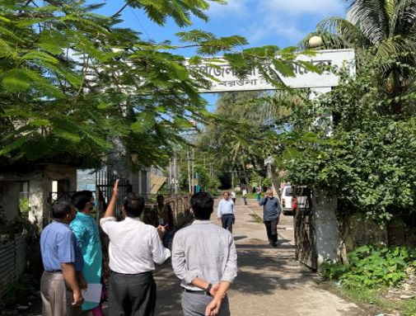
Fig-1: Front Gate of the Amtoli UHC

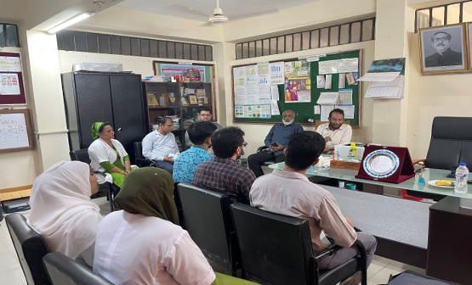
Fig-2: Meeting with the RMO and Medical Officers
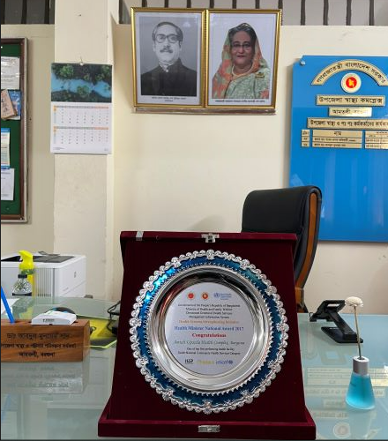
Fig-3: Health Complex is nationally awarded in 2017

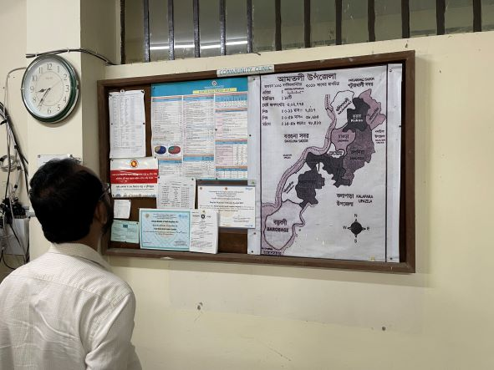
Fig-4: Improved Display System but not updated
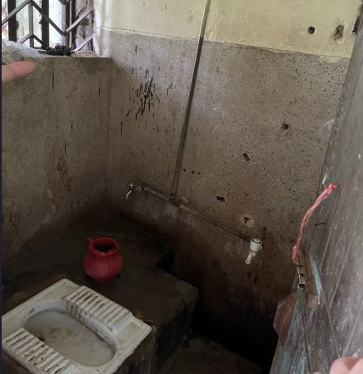
Fig-5: Unclean toilets in the health complex

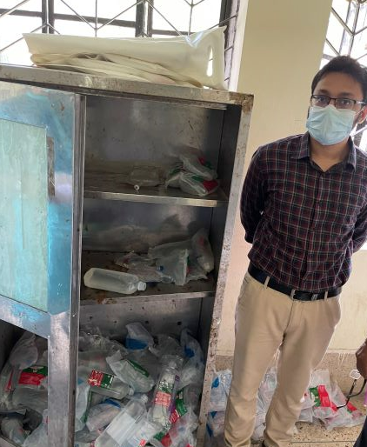

Fig-6: I/V-fluids not preserved safely and properly
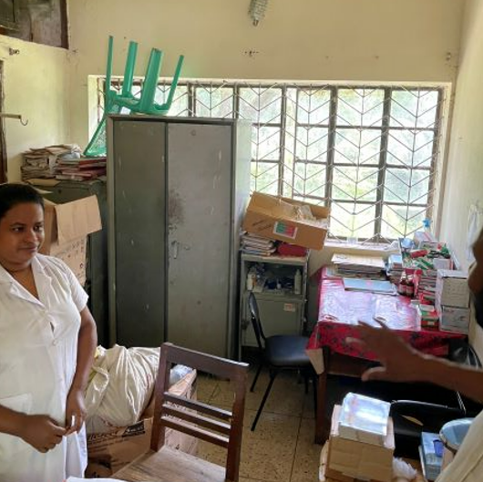
Fig-7: Unwanted items in nurse’s duty room
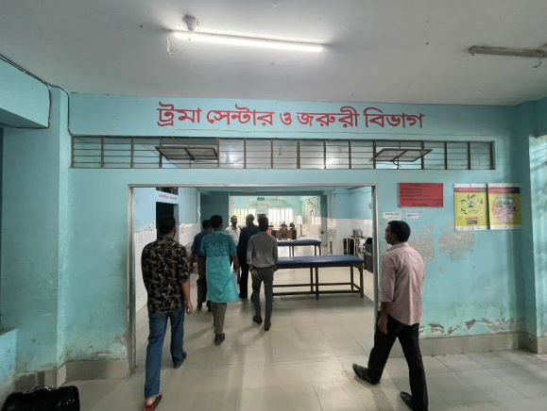

Status in HSS Score From Jan-July. (Total Dist. Hospital-64, Total UHC-423)
Name | Janu | Feb | Mar | April | May | June | July | Aug | Sep | OCT | Nov
Barguna  D-Hospi | 03 | 07 | 19 | 22 | 21 | 16 | 19 | 20 | 26 | 55
Amtoli  UHC | 319 | 200 | 255 | 298 | 207 | 368 | 353 | 278 | 284 | 292
Betagi  UHC | 306 | 314 | 304 | 332 | 340 | 337 | 341 | 368 | 366 | 413
Bamna  UHC | 221 | 162 | 290 | 230 | 279 | 277 | 279 | 306 | 292 | 263
Pathorg  hata  UHC | 209 | 291 | 347 | 258 | 248 | 270 | 385 | 303 | 312 | 315
Taltoli  UHC | - | - | - | - | - | - | - | - | - | -

